Pokhara University

Level: Bachelor | Semester – Spring | Year : 2007
Programme: BE |  | Full Marks: 100
Course: Electronic Devices |  | Time : 3hrs.

Candidates are required to give their answers in their own words as far as practicable.
The figures in the margin indicate full marks.

Attempt all the questions.

 | - What do you mean by nonlinear device? “Diode is a nonlinear Device” Do you agree or disagree? Justify it.  - Discuss the effects of temperature on V-I characteristics of P-N junction diode. Draw necessary waveforms. | 8  7
 | - What do you mean by reverse recovery time of PN junction diode? Explain with the help of necessary circuit diagram and waveforms.  - Refer the circuit diagram below:  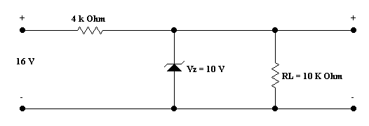  R_{s =}  Find :  - The output voltage  - Voltage across Rs = 4 KOhm  - The current through Zener diode | 8  7
 | - Explain the three configurations in transistor with their characteristic curve. Find the relation between α and β.  - What is faithful amplification? Explain the Early effect in the transistor. | 8  7
 | - For the given circuit overlaid, h_{fe} = 120, h_{ie} = 1560 Ω, R_{C} = 5.6 KΩ, R_{E} =1.2 KΩ, R_{B} = 270 KΩ.Find voltage gain (A_{v)}, current gain (A_{i)}, input impedance (Z_{in}), output impedance (Z₀).  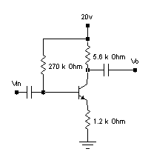  - For the following configuration find i) r_{e} and ii) voltage gain (A_{V}). Why this circuit is called as emitter follower? Give reasons. Given β = 100.  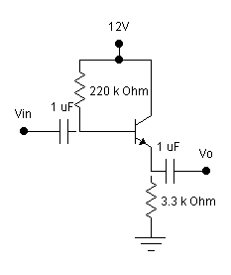 | 8  7
 | - Explain the construction and working principle of n-channel JFET. Also, draw its transfer characteristics.  - A JFET amplifier with stabilized biasing circuit shown in the figure has device parameter Vp = -2V, I_{DSS} = 5 mA, R_{D} = 910 Ohm, R_{S} = 2.29 KiloOhm, R₁ =12 MegaOhm, R₂ = 8.57 MegaOhm and V_{DD} = 24 Volt Find the Value of drain current I_{D} at operating point. Also, verify that FET will operate in pinch-off voltage.  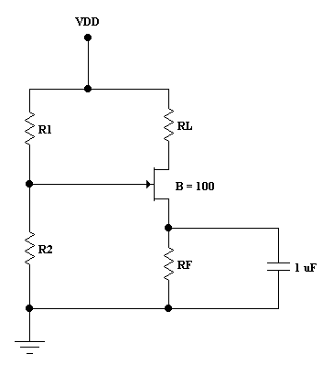  R_{D}  R_{S} | 8  7
 | - A half wave rectifier is fed with waveform V_{in} = V_{m} sinwt. Draw its output waveform and determine Vdc and Vrms. Assume diode is ideal.  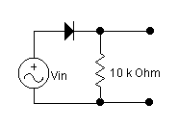  - Considering diode as ideal, sketch V₀ for the circuits shown below.  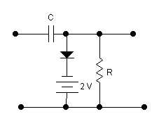  V_{in}  V_{o}  - Briefly explain shunt capacitor filter. | 5  5  5
 | Write short notes on (Any Two):  - Ebers Moll model of BJT  - High frequency t-model of BJT  - N – Depletion type MOSFET | 2×5

